

Use Case Specification: Quality eCL Notification
For

eCoaching Log

Change History Log

Date | Version | Description | Author
08/18/2014 | 1.0 | Initial Document | Doug Stearns

Table of Contents

1. Brief Description 5
2. Participating Actors 5
2.1 Primary 5
2.2 Secondary 5
3. Basic Flow of Events 6
3.1 System generates eCoaching eMail notification. 6
3.2 Employee (Quality Specialist) receives system generated eMail notification of eCoaching Log when coaching is Direct and status is Pending Employee Review, then the eMail notification will use the following: 6
3.3 Employee (Quality Specialist) selects hyper link to eCoaching Log Dashboard. 6
3.4 Employee (Quality Specialist) selects appropriate eCoaching Log to review. 6
3.5 Employee (Quality Specialist) selects acknowledgement of the coaching opportunity (required selection). 6
3.6 Employee (Quality Specialist) enters desired comments (free form text up to 3000 characters). 6
3.7 Employee (Quality Specialist) submits the acknowledgement. 6
3.8 Status of eCoaching Log becomes Completed. 6
4. Alternative Flows 7
4.1 Pending Quality Lead Review. [Step 3.2] 7
4.2 Customer Service Escalation [Step 3.2] 7
4.3 Outlier Data Feed [Step 3.2] 7
5. Preconditions 7
5.1 eCoaching Log for Quality successfully submitted. 7
5.2 System generated eMail notification sent to appropriate parties. 7
5.3 eCoaching Log database populated with correct and current hierarchy information for Quality Specialists, Quality Leads, Deputy Program Manager. 7
6. Postconditions 7
6.1 eCoaching Log reviewed and acknowledged by Quality Specialist. 7
6.2 eCoaching Log reviewed and acknowledged by Quality Lead. 7
7. Assumptions and Dependencies 7
7.1 Access to Quality module will be limited to those with the following job codes. 7
7.2 Basic from of eMail notification is as follows: 8
8. Business Rules 8
8.1 none 8
9. Technical Requirements 8
9.1 none 8
10. Activity Diagrams 9

Table of Figures
Figure 1 – Quality eCL Notification 9

Brief Description
eCoaching Log notifications and acknowledgment for Supervisors.

Participating Actors

Primary

Quality Specialists

Quality Leads

Secondary

Deputy Program Manager

Basic Flow of Events

System generates eCoaching eMail notification.

Employee (Quality Specialist) receives system generated eMail notification of eCoaching Log when coaching is Direct and status is Pending Employee Review, then the eMail notification will use the following:

Subject:
eCL: Pending Employee Review (<EMPLOYEE NAME>)
Message:
A new eCoaching Log has been entered on your behalf. Please click on the link below to review and verify the coaching opportunity received on <DATE>.

Employee (Quality Specialist) selects hyper link to eCoaching Log Dashboard.

Employee (Quality Specialist) selects appropriate eCoaching Log to review.

Employee (Quality Specialist) selects acknowledgement of the coaching opportunity (required selection).

Employee (Quality Specialist) enters desired comments (free form text up to 3000 characters).

Employee (Quality Specialist) submits the acknowledgement.

Status of eCoaching Log becomes Completed.

Alternative Flows

Pending Quality Lead Review. [Step 3.2]

Quality Lead receives system generated eMail notification of eCoaching Log when coaching is Indirect and status is Pending Quality Lead Review then the eMail notification will use the following:
Subject:
eCL: Pending Quality Lead Review (<EMPLOYEE NAME>)
Message:
A new eCoaching Log has been entered on behalf of <EMPLOYEE NAME> on <DATE> that requires your action. Please click on the link below to review the eCoaching log.

Quality Lead selects the hyper link to eCoaching Log Dashboard.

Quality Lead selects the appropriate eCoaching Log to review.

Quality Lead selects or enters date of coaching (required).

Quality Lead enters details of coaching session (free form text up to 3000 characters).

Quality Lead submits eCoaching Log review.

Status of eCoaching Log becomes Pending Employee Review.

Customer Service Escalation [Step 3.2]

There is no Customer Service Escalation at this time..

Outlier Data Feed [Step 3.2]

There is no Outlier Data Feed at this time.

Preconditions

eCoaching Log for Quality successfully submitted.

System generated eMail notification sent to appropriate parties.

eCoaching Log database populated with correct and current hierarchy information for Quality Specialists, Quality Leads, Deputy Program Manager.

Postconditions

eCoaching Log reviewed and acknowledged by Quality Specialist.

eCoaching Log reviewed and acknowledged by Quality Lead.

Assumptions and Dependencies

Access to Quality module will be limited to those with the following job codes.
Quality Leads | WACQ*, WSQ*
Managers | *50, *60, *70, WISO*, WSTE*, WPPM*, WPSM*, WEEX*,WISY*

Basic from of eMail notification is as follows:

To – [strto]
Subject – [strSubject]
** This is an automated email. Do not reply to this email. **
[strCtrMessage]
Please click here to open the eCL Dashboard [Link to Dashboard]
Form ID: [strFormID]
(Please do not respond to this automated notification)
Thank you,
eCoaching Log Team


Business Rules

none

Technical Requirements

none

Activity Diagrams
Below is the activity diagram for the use case that provides a visual depiction of the flow of events.

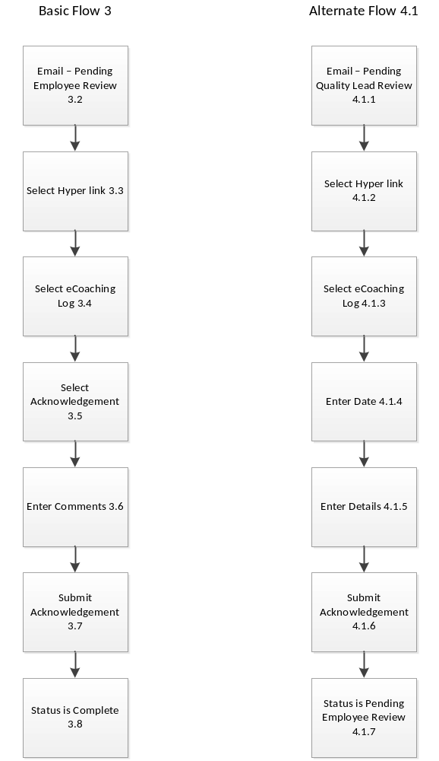

Figure 1 – Quality eCL Notification

